DIS-Greek-Figurine-

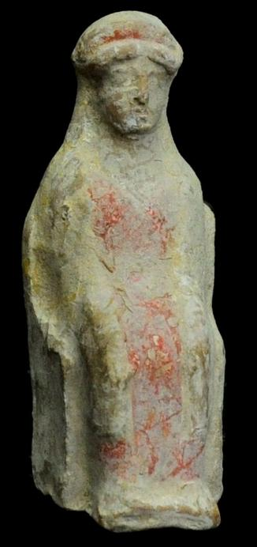US $1,450.00

Culture- Greek.  
  
Date-  6th - 5th Century B.C.Material- Pottery.  
  
Condition- Intact, with original polychromy mostly preserved.  
  
Provenance- Ex: American private collection; New York art market.  
Measurements- 3 3/4 in. High (9.5 cm.)

Seated female wearing Doric peplos, covered in pink red slip.